Trophic Pyramids

The average American consumes almost 2000 pounds of food each year. Obviously, we do not gain 2000 pounds of weight each year!
1. What happens to all the weight of the food we eat? Where do the atoms in the food molecules go?

The biomass of an organism is the mass of all the organic molecules in the organism. For each trophic level, the net rate of biomass production is the total mass of the organic molecules produced in a year minus the mass of the organic molecules used for cellular respiration. You can think of this as the amount of growth during the year; this includes any new individuals or growth of individuals in a trophic level, even if some things died.

Researchers assessed the net rate of biomass production at different trophic levels in a forest in New Hampshire. The relative size of the boxes in this flow chart indicates the relative magnitude of the net rate of biomass production for the producers vs. the primary consumers plus decomposers.

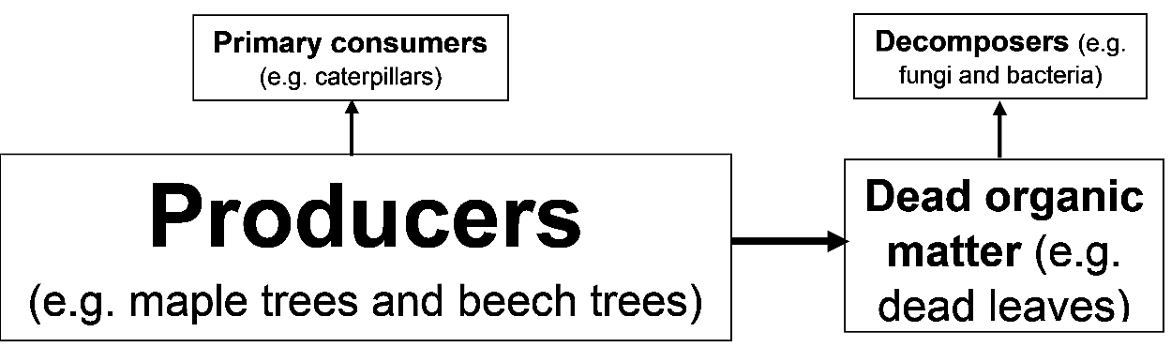

2. Add to this flowchart to show the reasons why the net rate of biomass production for the primary consumers plus decomposers is lower than the net rate of biomass production for the producers. (Hint: Think about question 1.)

3a. The left column of this table shows a summary food web, and the right column gives the rates of biomass production at different trophic levels in the forest. Circle the only rate of biomass production that would be possible for the secondary consumers.
 | Net Rate of Biomass Production (g/m²/year)
Secondary consumers (e.g. birds) | 30? 200? 1000?
↑
Primary consumers + Decomposers | 200
↑
Producers | 1000

3b. Explain your reasoning.

4. The width of each bar in this graph shows the net rate of biomass production for the producers and for the primary consumers plus decomposers in the forest. Add to the graph to show the net rate of biomass production for the secondary consumers. (See question 3a.)

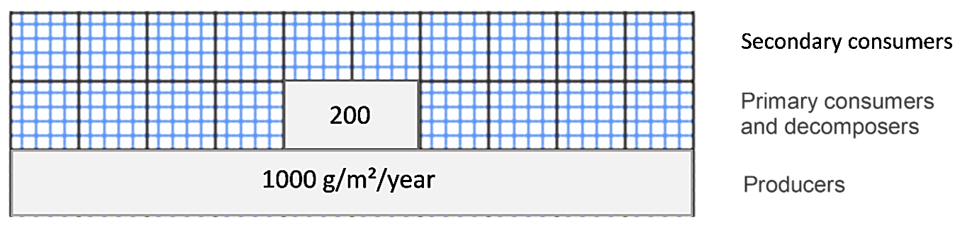

This type of information is often displayed in a trophic pyramid like this one.
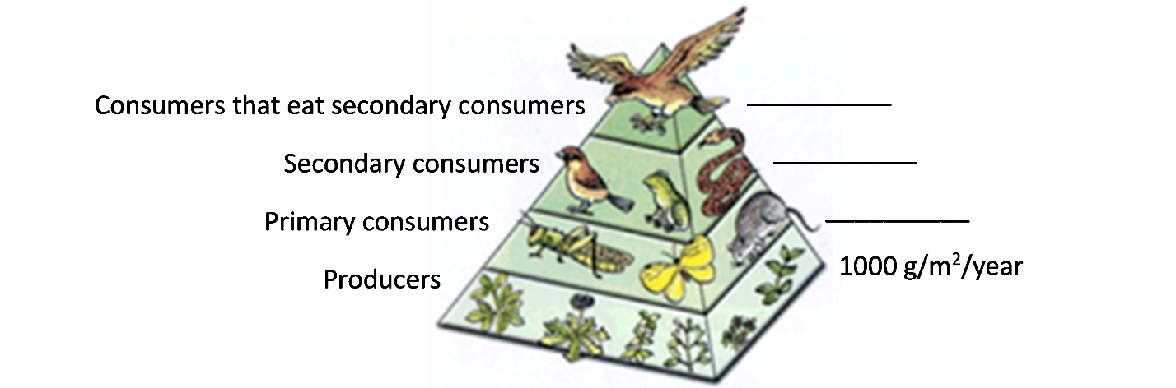
Scientists sometimes use the general estimate that the rate of biomass production at each trophic level is about 10% of the rate at the trophic level just below it.

5a. Use the 10% estimate to calculate the net rate of biomass production at each consumer trophic level in the above trophic pyramid.

5b. This 10% estimate is sometimes described as the 10% rule. What evidence from the forest ecosystem indicates that this 10% rule is not accurate in some cases?

6a. For lunch, Pat had a baked potato and Erin had a hamburger with no bun. They each consumed the same amount of biomass, but from different trophic levels. In comparison to the amount of land needed to produce Pat’s potato, how much land was needed to produce enough cattle feed to produce Erin’s hamburger?
- about 10% as much land to produce the hamburger
- about the same amount of land to produce the hamburger and the potato
- about 10 times as much land to produce the hamburger

6b. Explain your reasoning.

By Drs. Ingrid Waldron and Lori Spindler, Dept Biology, University of Pennsylvania. © 2021. This Student Handout and the Teacher Preparation Notes with instructional suggestions and background information are available at https://serendipstudio.org/exchange/bioactivities/trophicpyr.

